**Using scripts to test your code on a runner**

How to use essential GitHub Actions features for continuous integration (CI).

**In this article**

[Example overview](https://docs.github.com/en/actions/examples/using-scripts-to-test-your-code-on-a-runner" \l "example-overview)

[Features used in this example](https://docs.github.com/en/actions/examples/using-scripts-to-test-your-code-on-a-runner" \l "features-used-in-this-example)

[Example workflow](https://docs.github.com/en/actions/examples/using-scripts-to-test-your-code-on-a-runner" \l "example-workflow)

[Next steps](https://docs.github.com/en/actions/examples/using-scripts-to-test-your-code-on-a-runner" \l "next-steps)

[**Example overview**](https://docs.github.com/en/actions/examples/using-scripts-to-test-your-code-on-a-runner#example-overview)

This article uses an example workflow to demonstrate some of the main CI features of GitHub Actions. When this workflow is triggered, it automatically runs a script that checks whether the GitHub Docs site has any broken links.

The following diagram shows a high level view of the workflow's steps and how they run within the job:

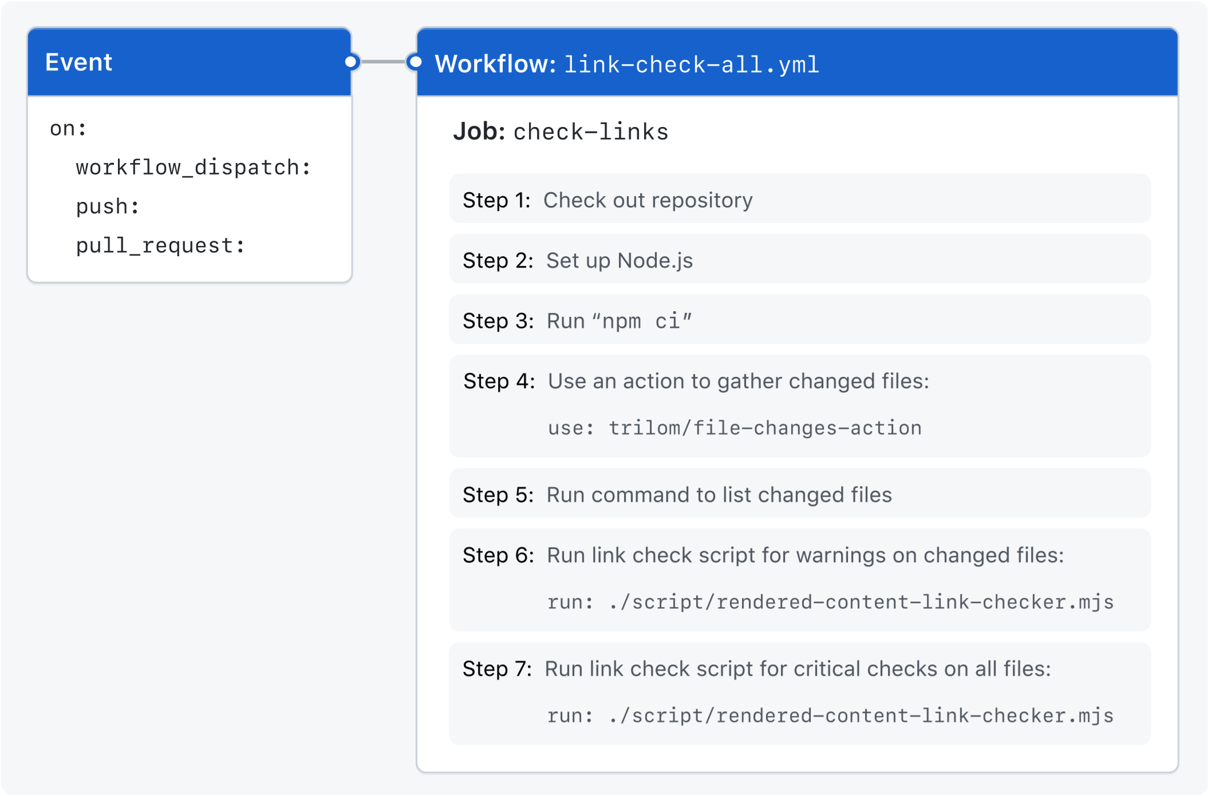

[**Features used in this example**](https://docs.github.com/en/actions/examples/using-scripts-to-test-your-code-on-a-runner#features-used-in-this-example)

The example workflow demonstrates the following capabilities of GitHub Actions.

| **Feature** | **Implementation** |
| --- | --- |
| Triggering a workflow to run automatically | [push](https://docs.github.com/en/actions/using-workflows/events-that-trigger-workflows#push) |
| Triggering a workflow to run automatically | [pull_request](https://docs.github.com/en/actions/using-workflows/events-that-trigger-workflows#pull_request) |
| Manually running a workflow from the UI | [workflow_dispatch](https://docs.github.com/en/actions/using-workflows/events-that-trigger-workflows#workflow_dispatch) |
| Setting permissions for the token | [permissions](https://docs.github.com/en/actions/using-jobs/assigning-permissions-to-jobs) |
| Controlling how many workflow runs or jobs can run at the same time | [concurrency](https://docs.github.com/en/actions/using-jobs/using-concurrency) |
| Running the job on different runners, depending on the repository | [runs-on](https://docs.github.com/en/actions/using-jobs/choosing-the-runner-for-a-job) |
| Cloning your repository to the runner | [actions/checkout](https://github.com/actions/checkout) |
| Installing node on the runner | [actions/setup-node](https://github.com/actions/setup-node) |
| Using a third-party action | [trilom/file-changes-action](https://github.com/trilom/file-changes-action) |
| Running a script on the runner | Using ./script/rendered-content-link-checker.mjs |

[**Example workflow**](https://docs.github.com/en/actions/examples/using-scripts-to-test-your-code-on-a-runner#example-workflow)

The following workflow was created by the GitHub Docs Engineering team. To review the latest version of this file in the [github/docs](https://github.com/github/docs) repository, see [check-broken-links-github-github.yml](https://github.com/github/docs/blob/main/.github/workflows/check-broken-links-github-github.yml).

The following workflow renders the content of every page in the documentation and checks all internal links to ensure they connect correctly.

YAML

BesideInline

name: 'Link Checker: All English'

This defines the name of the workflow as it will appear in the "Actions" tab of the GitHub repository.

on:

The on key lets you define the events that trigger when the workflow is run. You can define multiple events here. For more information, see "[Triggering a workflow](https://docs.github.com/en/actions/using-workflows/triggering-a-workflow#using-events-to-trigger-workflows)."

workflow_dispatch:

Add the workflow_dispatch event if you want to be able to manually run this workflow from the UI. For more information, see [workflow_dispatch](https://docs.github.com/en/actions/using-workflows/events-that-trigger-workflows#workflow_dispatch).

push:

branches:

- main

Add the push event, so that the workflow runs automatically every time a commit is pushed to a branch called main. For more information, see [push](https://docs.github.com/en/actions/using-workflows/events-that-trigger-workflows#push).

pull_request:

Add the pull_request event, so that the workflow runs automatically every time a pull request is created or updated. For more information, see [pull_request](https://docs.github.com/en/actions/using-workflows/events-that-trigger-workflows#pull_request).

permissions:

contents: read

pull-requests: read

This modifies the default permissions granted to GITHUB_TOKEN. This will vary depending on the needs of your workflow. For more information, see "[Assigning permissions to jobs](https://docs.github.com/en/actions/using-jobs/assigning-permissions-to-jobs)."

In this example, the pull-requests: read permission is needed for the trilom/file-changes-action action that is used later in this workflow.

concurrency:

group: '${{ github.workflow }} @ ${{ github.event.pull_request.head.label || github.head_ref || github.ref }}'

cancel-in-progress: true

The concurrency key ensures that only a single workflow in the same concurrency group will run at the same time. For more information, see "[Using concurrency](https://docs.github.com/en/actions/using-jobs/using-concurrency)." concurrency.group generates a concurrency group name from the workflow name and pull request information. The || operator is used to define fallback values. concurrency.cancel-in-progress cancels any currently running job or workflow in the same concurrency group.

jobs:

The jobs key groups together all the jobs that run in the workflow file.

check-links:

This line defines a job with the ID check-links that is stored within the jobs key.

runs-on: ${{ fromJSON('["ubuntu-latest", "self-hosted"]')[github.repository == 'github/docs-internal'] }}

The runs-on key in this example configures the job to run on a GitHub-hosted runner or a self-hosted runner, depending on the repository running the workflow.

In this example, the job will run on a self-hosted runner if the repository is named docs-internal and is within the github organization. If the repository doesn't match this path, then it will run on an ubuntu-latest runner hosted by GitHub. For more information on these options, see "[Choosing the runner for a job](https://docs.github.com/en/actions/using-jobs/choosing-the-runner-for-a-job)."

steps:

The steps key groups together all the steps that will run as part of the check-links job. Each job in a workflow has its own steps section.

- name: Checkout

uses: actions/checkout@v4

The uses key tells the job to retrieve the action named actions/checkout. This is an action that checks out your repository and downloads it to the runner, allowing you to run actions against your code (such as testing tools). You must use the checkout action any time your workflow will use the repository's code or you are using an action defined in the repository.

- name: Setup node

uses: actions/setup-node@v3

with:

node-version: 16.13.x

cache: npm

This step uses the actions/setup-node action to install the specified version of the Node.js software package on the runner, which gives you access to the npm command.

- name: Install

run: npm ci

The run key tells the job to execute a command on the runner. In this example, npm ci is used to install the npm software packages for the project.

- name: Gather files changed

uses: trilom/file-changes-action@a6ca26c14274c33b15e6499323aac178af06ad4b

with:

fileOutput: 'json'

This step uses the trilom/file-changes-action action to gather all the changed files. This example is pinned to a specific version of the action, using the a6ca26c14274c33b15e6499323aac178af06ad4b SHA.

In this example, this step creates the file "${{ env.HOME }}/files.json", among others.

- name: Show files changed

run: cat $HOME/files.json

To help with verification, this step lists the contents of files.json. This will be visible in the workflow run's log, and can be useful for debugging.

- name: Link check (warnings, changed files)

run: |

./script/rendered-content-link-checker.mjs \

--language en \

--max 100 \

--check-anchors \

--check-images \

--verbose \

--list $HOME/files.json

This step uses the run command to execute a script that is stored in the repository at script/rendered-content-link-checker.mjs and passes all the parameters it needs to run.

- name: Link check (critical, all files)

run: |

./script/rendered-content-link-checker.mjs \

--language en \

--exit \

--verbose \

--check-images \

--level critical

This step also uses run command to execute a script that is stored in the repository at script/rendered-content-link-checker.mjs and passes a different set of parameters.

[**Next steps**](https://docs.github.com/en/actions/examples/using-scripts-to-test-your-code-on-a-runner#next-steps)

* To learn about GitHub Actions concepts, see "[Understanding GitHub Actions](https://docs.github.com/en/actions/learn-github-actions/understanding-github-actions)."
* For more step-by-step guide for creating a basic workflow, see "[Quickstart for GitHub Actions](https://docs.github.com/en/actions/quickstart)."
* If you're comfortable with the basics of GitHub Actions, you can learn about workflows and their features at "[About workflows](https://docs.github.com/en/actions/using-workflows/about-workflows)."